My Core Value
Journey Book

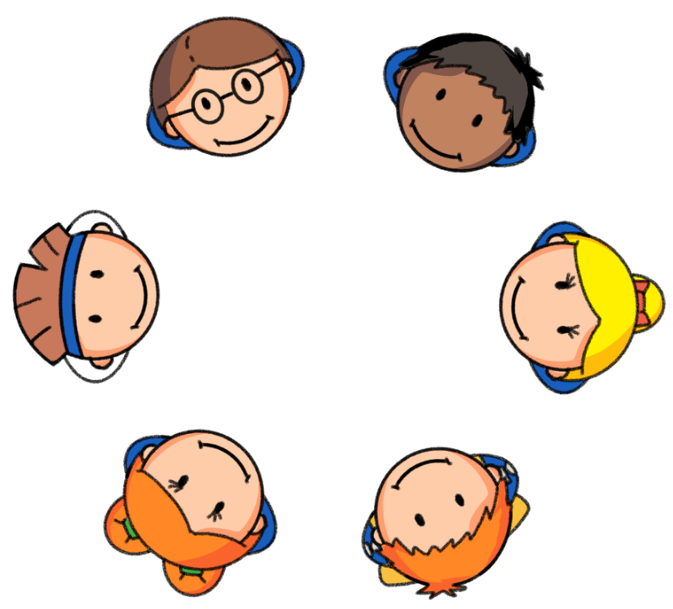



Raheem Respect
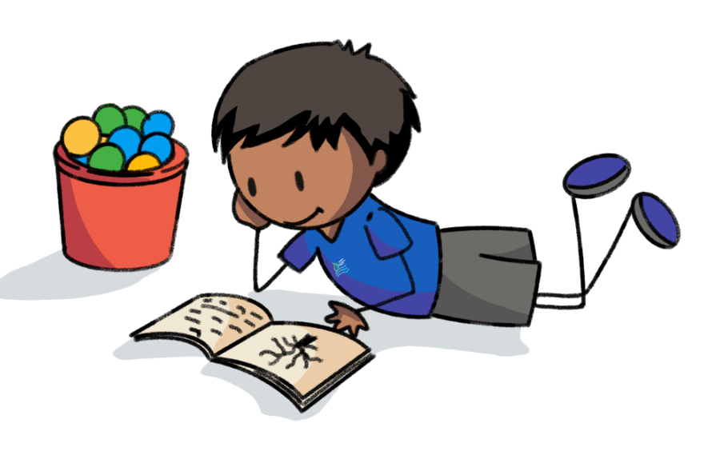

Raheem Respect
Raheem Respect knows that looking after others and their feelings is really important. He always tries hard to listen when people are talking to him and knows he might hear something important when others are giving him instructions.

Raheem loves learning about other people’s families, their backgrounds and cultures by asking lots of questions.

He loves to play and knows how important it is to take turns. He always looks after toys and equipment so that they are ready to be used and shared with others.

He is also very polite - never forgetting to say ‘Please’ and ‘Thank you’.

Raheem feels sad if people show disrespect to others or to equipment in school. He is a true respect ambassador.
My Respect Journey | Yr 1 | Yr 2 | Yr 3 | Yr 4 | Yr 5 | Yr 6
I can say ‘Please’ and ‘Thank you’ without being prompted
I can listen to people and follow instructions
I can look after toys, equipment and the school environment
I can share and take turns
I can share my thoughts about my community and compare it to other cultures, understanding that people are different
I treat others the way I want to be treated

My Respect Journey… Reflections
Year 1 | Pupil Comment: | Score: /6
Year 2 | Pupil Comment | Score: /6
Year 3 | Pupil Comment | Score: /6
Year 4 | Pupil Comment | Score: /6
Year 5 | Pupil Comment | Score: /6
Year 6 | Pupil Comment | Score: /6

