My Core Value
Journey Book

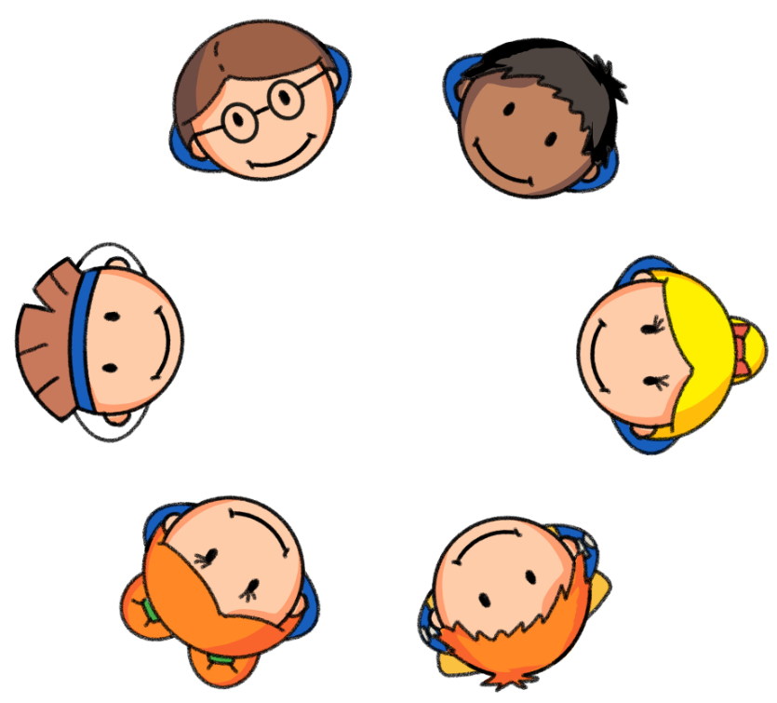

Tabby Trust
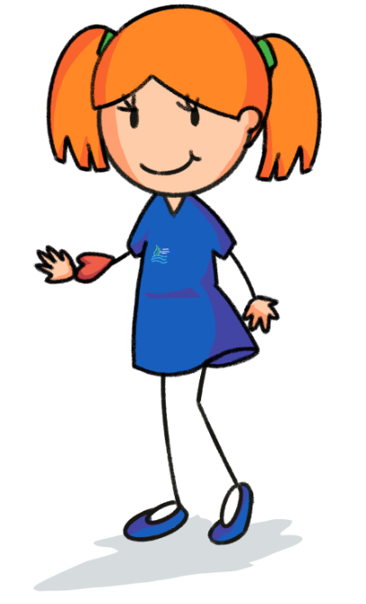

Tabby Trust
Trust is a key value in school and something that is essential when forging relationships later in life. Tabby knows that building a relationship is a really big deal. For a relationship to become effective, you have to build trust. Tabby knows that this could be with a friend, a parent or a trusted adult.
A key area of trust is openness and honesty. She knows that if all of her friends were open and honest then the school would be a lovely place to be. As honesty grows, trusts grows with it.
Tabby always wears her heart on her sleeve and isn’t afraid to show her emotions and share her feelings with those who care. She has a really big heart and hates being let down by other people. If the trust is broken then it is extremely hard to get back – she never forgets this!
REMEMBER… Whether it is a friendship or a relationship all bonds are built on trust and if broken can take a long time to repair.
My Trust Journey | Yr 1 | Yr 2 | Yr 3 | Yr 4 | Yr 5 | Yr 6
I know how to build a relationship.
I have built a relationship with a trusted adult and other peers.
I know who I can trust in school.
I am open and honest when I am in school.
I know when to share my feelings and emotions.
I know how to build bonds if I’m let down.

My Trust Journey… Reflections
Year 1 | Pupil Comment: | Score: /6
Year 2 | Pupil Comment | Score: /6
Year 3 | Pupil Comment | Score: /6
Year 4 | Pupil Comment | Score: /6
Year 5 | Pupil Comment | Score: /6
Year 6 | Pupil Comment | Score: /6

