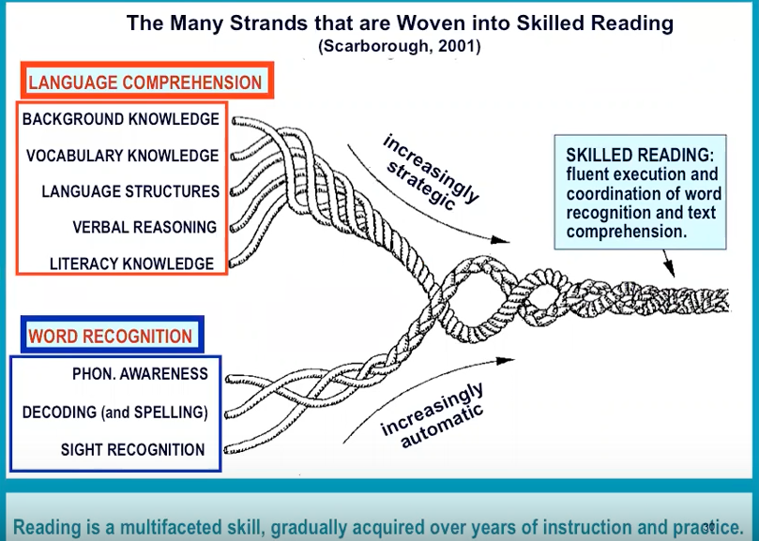

Phonics continues to be a significant strand for skilled readers.

The Fundamentals of Effective Phonics Practice:
- High quality systematic synthetic phonics programme is followed and children are taught consistently to use phonics as the route to reading unknown words
- All staff involved in delivery and monitoring the provision are fully trained
- Effective provision is made for all abilities
- A ‘can-do’ attitude permeates everything with full expectation that all children will attain or exceed expected standards
- Children practice early reading with fully decodable books that are matched to their phonic knowledge, for this we use Collins Big Cats Letters and sounds books that are decodable and match each letters and sounds phase
- Development of word-reading ability is fully balanced by the development of vocabulary, comprehension and a love of books
- All staff ensure help parents and careers to understand and support the teaching of phonics

The Key features of Effective Letters and Sounds Practice:
- Consistency
- Progression and pace (needs to apply to all children)
- Linking phonics to reading and writing (it all needs to link)
- Direct teaching
- Fast, repeated practice
- Use of fully decodable books
- Early identification of children in danger of falling behind
- Effective keep-up support
CONSISTENCY
- Pronunciation of phonemes
- Use of terminology
- Sequence and progression
- Teaching routines and mantras
Reading needs to be woven throughout ALL of the CURRICULUM

Technical Vocabulary:
Before teaching any phonics lesson, all staff need to ensure they are using the correct technical vocabulary. In order for our children to achieve and make progress in phonics, the vocabulary that they hear needs to be CONSISTENT from every adult across school.

Every member of staff needs to make sure they are familiar with and know what each statement below means.

phoneme  the smallest unit of sound in a word – often referred to as ‘a sound’ | grapheme  a letter (or sequence of letters) that represent(s) a phoneme | grapheme-phoneme correspondence (GPC)  the match between a phoneme and a grapheme
blend  squashing sounds (phonemes) together to make larger units such as syllables or words  READING | segment  breaking words or parts of words into phonemes  SPELLING (WRITING) | sound (as a verb)  saying the phonemes that each grapheme represents in order to blend them
recognition  saying the phoneme when shown the grapheme | recall  finding or writing the grapheme that represents a particular phoneme | polysyllabic word  a word with more than one syllable
digraph  a phoneme that is represented by 2 letters | trigraph  a phoneme that is represented by 3 letters | split digraph  a digraph that is separated by 1 or more consonants within a word
consonant  a speech sound in which the breath is at least partly obstructed | adjacent consonant  2 or more consonants next to each other at the beginning or end of a word or syllable | vowel  a speech sound pronounced without any stricture in the vocal tract
alternative graphemes  different representations of a phoneme in a word | oral blending  say phonemes in the word and blend in your head or out loud | letter name  ensures precision ‘This letter A makes the sound a.’

Pure Sounds:

CONSISTENCY is vital when teaching phonics and I can’t express how important it is for all staff to use the correct pronunciation for each phoneme.

s sat | a ant | t ten | p party | i pig | n net
m moon | d dig | g get | o cot | c,k kick | e hen
u up | r red | h hop | b bed | f fish | l lip
j jam | v van | w witch | x box | y yes | z zip
qu queen | ng sing | ch chip | sh shop | th this  th thick | nk pink
ai rain | oa goat | igh light | ee sheep | or thorn | ar farm
oo book | oo moon | ow owl | oi coin | ur turn | air chair
er flower |  |  | ear hear

Expectations:

The next thing that is vital is ensuring that we all know the expectations for phonics.
Do we all know what phase children should be on at each stage during their phonics journey?

Nursery
Across nursery children will be taught all 7 aspects of phase 1
RECEPTION
Autumn 1 | Phase 2 – phonemes
Autumn 2 | Phase 2 – digraphs
Spring 1 | Phase 3
Spring 2 | Review phase 3 – including longer words & words with double letters
Summer 1 | Phase 4 – short vowels with adjacent consonants
Summer 2 | Phase 3 long vowel graphemes with adjacent consonants
YEAR 1
Autumn 1 | Consolidate & Review Phase 3 & 4  Phase 5 (ai-ay/ow-ou/oi-oy/ea-ea)
Autumn 2 | Phase 5 (ur-ir/igh-ie/oo-ue/yoo-u/oa-o/igh-i/ai-a/ee-e/ai-a_e/igh-i_e/oa-o_e/oo-u_e/ee-e_e/00-ew/ee-ie/or-aw)
Spring 1 | Phase 5 (ee-y/e-ea/w-wh/oa-oe/igh-y/oa-ow/j-g/f-ph/l-le/s-c/v-ve/u-o_e,ou/z-se/ee-ey/oo-ui,ou)
Spring 2 | Phase 5 (ur-or/oo-u,oul/air-are/or-au,aur,oor,al/ch-tch,ture/ar-all,a/or-a/o-a/air-ear,ere/ur-ear/r-wr/s-st,sc/c-ch/sh-ch/z-ze)
Summer 1 | Phonics screening check review – no new GPCs
Summer 2 | Phase 5 (ai-eigh,aigh,ey,ea/n-kn,gn/m-mb/ear-ere,eer/zh-su,si/j-dge/i-y/j-ge/sh-ti,ssi,si,ci/or-augh,our,oar,ore)

Progression:

Each phase has a teaching sequence to follow.
Phase | Knowledge | Skills | Tricky Words
1 | A wide range of stories, songs, chants & rhymes.  An extensive vocabulary | Speck well & listen attentively  Distinguish & articulate sounds (phonemes) in speech  Orally blend & segment
2 | single letter sounds  s a t p i n  m d g o c k ck e  u r h b f l  ss ck ff ll  other single letter sounds & consonant digraphs  ff, ll, ss, j, v, w, x, y, z, zz, qu, ch, sh, th, ng, nk  - words with – s added at end (hats/sits)  - words ending -s /z/(his) & with -s /z/ added at the end (bags) | Blend to read vc & cvc words including 2 syllable words  Segment to spell vc & cvc words | Is, I, the  As, and, has, his, her, go, no, to, into, she, he, we, me, be
3 | Vowel digraphs &trigraphs  ai, ee, igh, oa, oo, oo, ar, or, ur, ow, oi, ear, air, er  - words with double letters  - longer words  Review phase 3  - longer words, including those with double letters  - words with -s /z/ in the middle  - words with -es /z/ at the end  - words with -s /s/ and /z/ at the end | Blend to read vc & cvc words including 2 syllable words  Segment to spell vc & cvcv words including 2 syllable words | Was, you, they, my, by, all, are, sure, pure
4 | Short vowels with adjacent consonants  - CVCC, CCVC, CCVCC, CCCVC, CCCVCC  - longer words and compound words  - words ending in suffixes: -ing, -ed /t/, -ed /id/ /ed/, -est  Phase 3 long vowel graphemes with adjacent consonants  - CVCC, CCVC, CCCVC, CCV, CCVCC  - words ending in suffixes: ing, -ed /t/, -ed /id/ /ed/, -ed /d/ -er, -est  - longer words and compound words | Blend to read words with adjacent consonants  Segment to spell words with adjacent consonants | Said, so, have, like, some, come, love, do, were, here, little, says, there, when, what, one, out, today
5 | /ai/ ay play  /ow/ ou cloud  /oi/ oy toy  /ea/ ea each  /ur/ ir bird  /igh/ ie pie  /oo/ /yoo/ ue blue, rescue  /yoo/ u unicorn  /oa/ o go  /igh/ i tiger  /ai/ a paper  /ee/ e he  /ai/ a_e snake  /igh/ i_e time  /oa/ o_e home  /oo/ /yoo/ u_e rude cute  /ee/ e_e these  /oo/ /yoo/ ew chew new  /ee/ ie shield  /or/ aw claw  /ee/ y funny  /e/ ea head  /w/ wh wheel  /oa/ oe, ou toe shoulder  /igh/ y fly  /oa/ ow snow  /j/ g giant  /f/ ph phone  /l/ le al apple metal  /s/ c ice  /v/v ve give  /u/ o_e o ou some mother young  /z/ se cheese  /s/ se ce mouse fence  Ee/ ey donkey  /oo/ ui ou fruit soup  /ur/ or word  /oo/ u oul awful could  /air/ are share  /or/ au aur oor al author dinosaur floor walk  /ch/ tch ture match adventure  /ar/ al a half father  /or/ a water  /o/ a want  /air/ ear ere bear there  /ur/ ear learn  /r/ wr wrist  /s/ st sc whistle science  /c/ ch school  /sh/ ch chef  /z/ ze freeze  /ai/ eigh aigh ey ea eight straight grey break  /n/ kn gn knee gnaw  /m/ mb thumb  /ear/ ere eer here deer  /zh/ su si treasure vision  /j/ dge bridge  /i/ y crystal  /j/ ge large  /sh/ ti ssi si ci potion mission mansion delicious  /or/ augh our oar ore daughter pour oar more | No new strategies or skills | Phases 2-4 the, to, into, I, no, go, of, he, she, we, me, be, was, you, they, all, are, my, by, sure, pure, said, have, like, so, do, some, come, love, were, there, little, one, when, out, what, says, here, today  Their, people, oh, your, Mr, Mrs Ms, ask, could, would, should, our, house, mouse, water, want  Any, many, again, who, whole, where, two, school, call, different, thought, through, friend, work  Once, laugh, because, eye  Busy, beautiful, pretty, hour, move, improve, parents, shoe

ASSESSMENT

Little Wandle Tracking will be used at the end of each phase to measure each child’s progress and to identify individual gaps.

The Teaching Sequence:

Each session needs a clear Learning Objective

REVISIT & REVIEW
Activate prior knowledge – recall find phonemes on a mat/write them – recount use flash cards or IWB for recognition
Practise recognition and recall of previously taught GPCs
Practise oral blending and segmentation/practice fluent reading-spelling/tricky words
It needs to be fast pace
TEACH
Explicitly teach a new GPC and or a new Tricky word
When teaching a GPC
*Rehearse articulation of phoneme and make links with familiar vocabulary
*Introduce grapheme that most commonly represents the phoneme using its name and sound
*Rehearse distinguishing the grapheme from a mnemonic and from other taught graphemes
*Model how the letter is formed and practice writing it, when using IWB ensure lined flip chart is used so that letter formation can be modeled correctly
*Model using the new letter – blending and segmenting one or two new words with letter cards or (in phase 3) locating the new digraph or trigraph within words
Teach blending or segmenting with letters
Model/memorization
When teaching a tricky word – model the part of the word that is tricky
PRACTISE AND APPLY
Practise reading or spelling words using taught letters
Read or write a caption using high frequency and decodable words
At this part the children need to be having a go and practicing what they know and what they have been taught

REVISE KEY LEARNING FOR LESSON

APPLY TO READING
Use phrases or sentences at the end of the session that are linked to what has been taught

DO NOT USE CURSIVE WRITING DURING A PHONICS LESSON

